Experiment 22: PS2 rocker experiment
PS2 rocker can be used to control the car and so on, the structure is mainly two 10K potentiometer, there is a button switch. Five ports are VCC, X, Button, Y, GND.,, respectively.
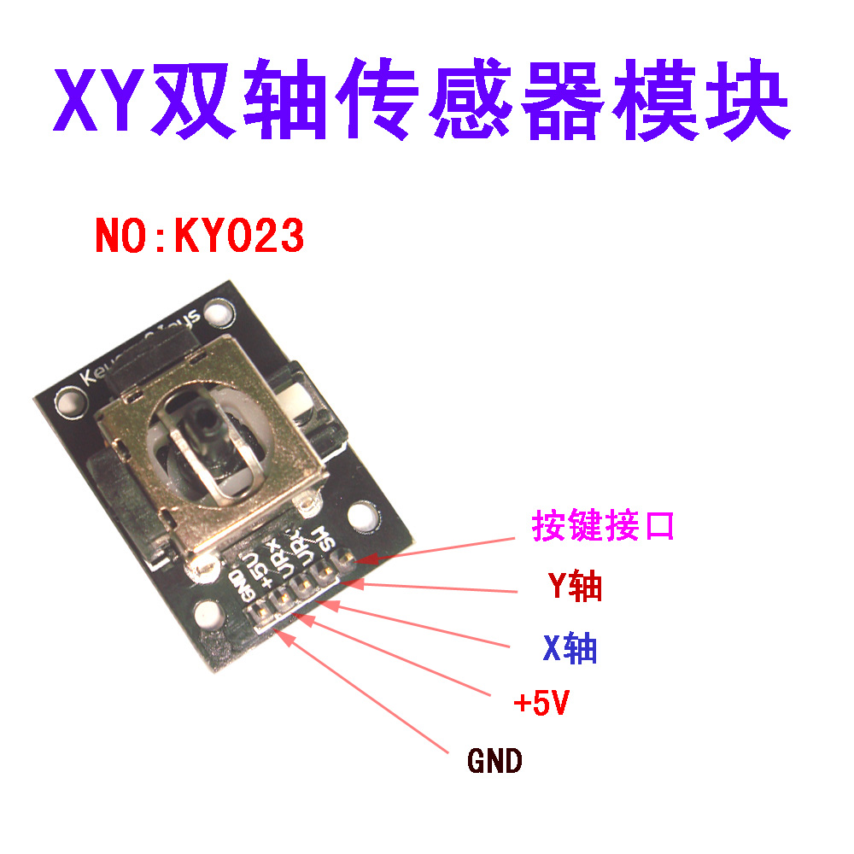
Wiring diagram:
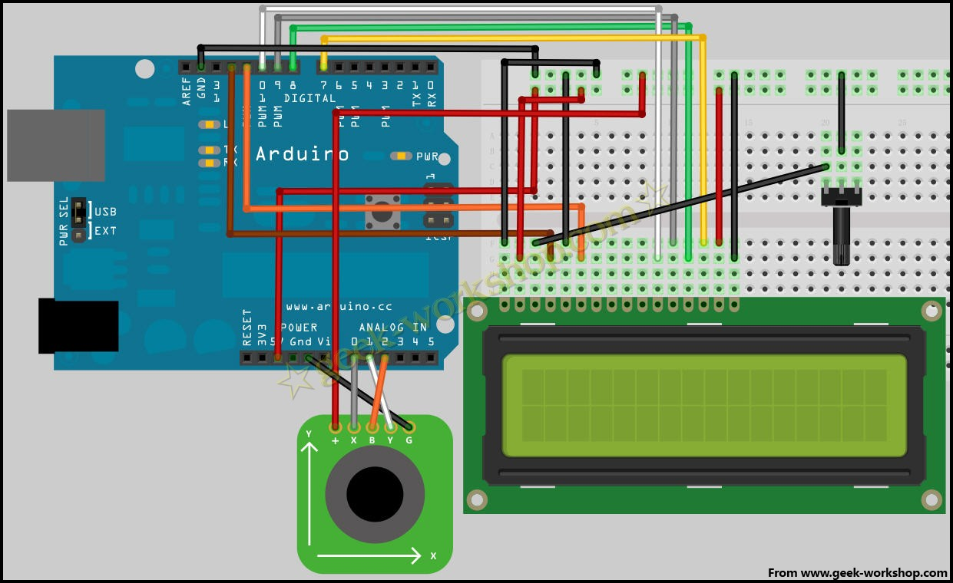

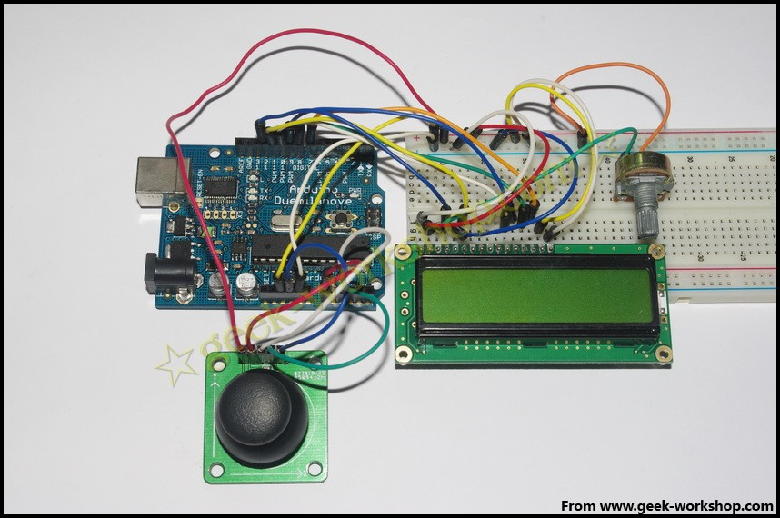
program code
#include <LiquidCrystal.h> //Call LiquidCrystal comes with the Arduino Library
LiquidCrystal lcd(12, 11, 10, 9, 8, 7);//Set interface
int xpotPin = 0; //Set the analog port 0 for the X signal input port
int ypotPin = 1; //Set the analog port 1 for the Y signal input port
int xval=0; //Set variable
int yval=0;
void setup()
{
pinMode(xpotPin,INPUT);//
pinMode(ypotPin,INPUT);//
lcd.begin(16, 2); //First of LCD
delay(1000); //Delay 1000ms
}
void loop ()
{
xval = analogRead(xpotPin); //The value of the xval variable is the value that is read from the 0 signal port.
yval = analogRead(ypotPin); //The value of the yval variable is the value that is read from the 1 signal port.
lcd.clear(); //clear display
lcd.setCursor(0, 0) ; //Set the cursor position to the first line
lcd.print("X="); //Make the screen display text X=
lcd.print(xval);
lcd.setCursor(7, 0) ; //Set the cursor position to the first line eighth positions
lcd.print("Y="); //Enable the screen to display text Y=
lcd.print(yval);
delay(100); //Delay for 0.1 seconds, here is the refresh rate
}

Experimental results: push the rocker, the resistance value of the potentiometer is changed, the corresponding voltage will also change, digital LCD screen is each axis digital output voltage.
The following is the experimental effect chart：
